Assignment 2
Mandelbrot Fractal — Parallel Computing
Hand-in Report
April 6, 2025

Introduction
The Mandelbrot set is a fractal defined over the complex plane. For each point c in the plane, the sequence zₙ₊₁ = zₙ² + c is iterated starting from z₀ = 0. A point belongs to the set if |z| never exceeds 2 after a maximum number of iterations (max_iter). The points that escapes are assigned the iteration count at which they diverged, producing the colored boundary image.

This set is intensive because the iteration must be performed independently for every pixel in the grid. For a 1000x1000 grid with max_iter= 100, this counts up to 100 million individual floating-point operations. This is the reason it is good for parallelization, as each pixel’s computation is completely independent of all others.

This report describes three implementations of the Mandelbrot algorithm and benchmarks for their performance against each other:
- A vectorized NumPy baseline (single process, no explicit parallelism)
- A parallel multiprocessing implementation using Python's multiprocessing.
- A Dask implementation exploiting multi-core local execution and distributed cluster execution
For each implementation, the report presents experimental results, analysis of the key parameters, and interpretation of the observed behavior.

Implementations
The baseline implementation (mandelbrot_numpy) processes the entire complex grid as a single NumPy array with no parallelism. It acts as a reference against which all speedup values calculated. All pixels are iterated up to max_iter times.

The parallel implementation (mandelbrot_multiprocessing.py) distributes work across P worker processes using multiprocessing. The complex grid is divided into horizontal row-chunks of a configurable size. Each chunk is sent to worker process. The key design parameter is chunk_size (the no. of rows per task). If the chunk size is too small then the value creates excessive inter-process communication (IPC) overhead; too large value will lead to load imbalance.

The Dask implementation wraps the complex grid in a Dask arrat and applies the worker function using map.blocks. This approach is crucial: rather than allowing Dask to schedule each interation as a separate task which can create scheduling overhead. Map.block treates the entire mandelbrot_block function as one computation per chunk. The implementation supports bothlocal multi-core execution using Dask’s default threaded scheduler and distributed cluster execution. The chunk_size parameter controls the parallelism in both cases.

Benchmarking Methodology
All experiments were conducted on the same machine under consistent conditions. The following settings were used throughout unless otherwise stated:

Parameter | Value
Grid resolution | 1000 × 1000 pixels (most experiments)
Large grid (final comparison) | 2000 × 2000 pixels
Maximum iterations (max_iter) | 100
Repetitions per measurement | 3 (mean reported)
Timing method | time.perf_counter() — high-resolution clock
Process counts tested (P) | 1, 2, 4, 8
Chunk sizes tested (multiprocessing) | 10, 25, 50, 100, 200, 500 rows
Chunk sizes tested (Dask) | 32, 64, 128, 250, 500, 1000

Experimental Results

Mandelbrot output –
The image below shows the Mandelbrot set computed by the parallel multiprocessing implementation and the Dask implementation respectively. Both are visually identical which confirms that chunking and reassembly does not show numerical error.
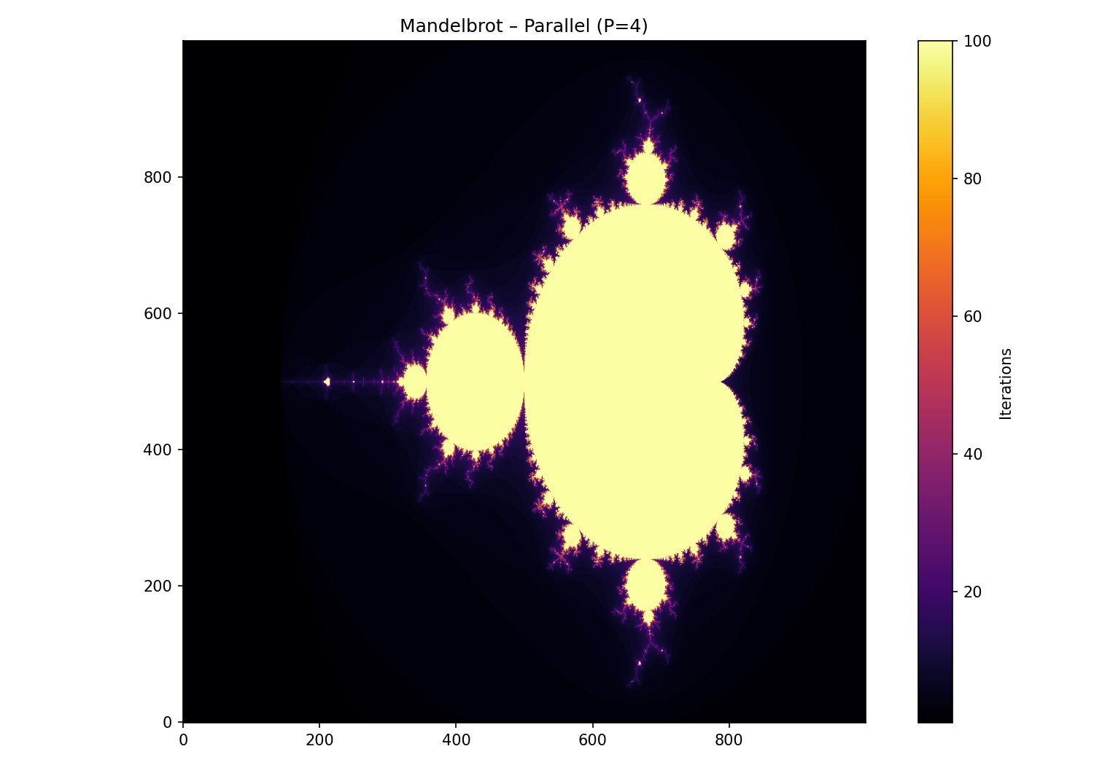

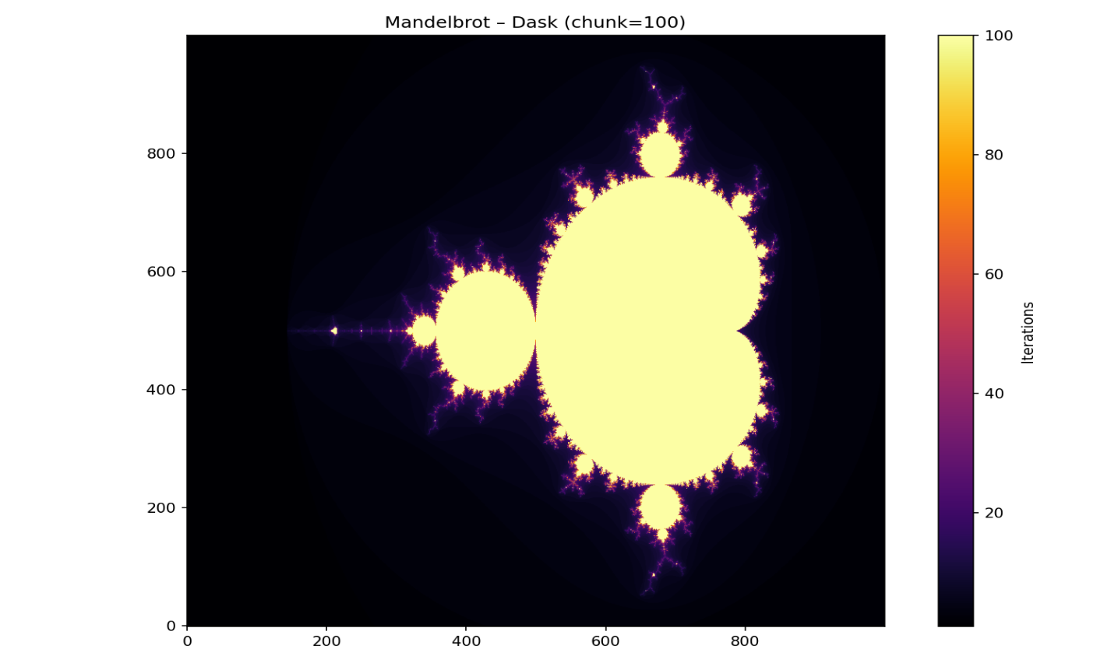

Multiprocessing – effect of chunk size
The chart below shows mean execution time as a function of chunk size for each process count P ∈ {1, 2, 4, 8}.

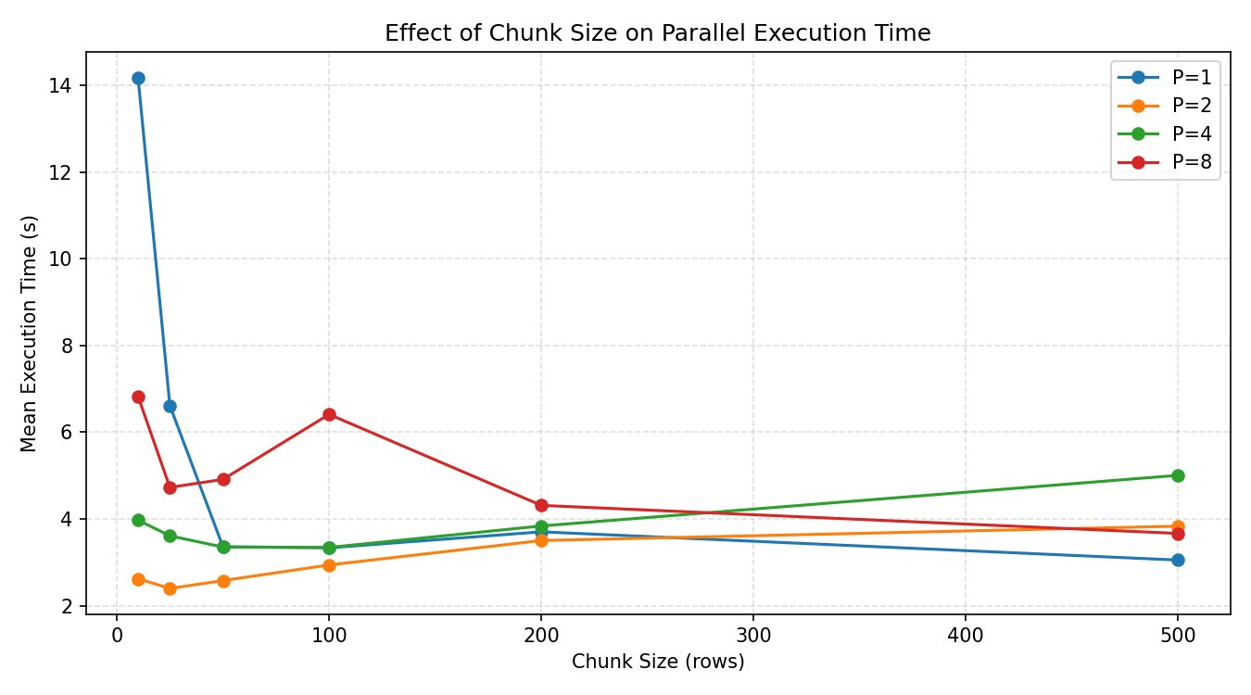
Mean execution time vs. chunk size for P = 1, 2, 4, 8 processes. Grid: 1000×1000, max_iter=100, 3 repetitions.

P | chunk=10 | chunk=25 | chunk=50 | chunk=100 | chunk=200 | chunk=500
1 | 14.18s | 6.61s | 3.36s | 3.33s | 3.70s | 3.05s
2 | 2.62s | 2.40s | 2.58s | 2.94s | 3.50s | 3.83s
4 | 3.97s | 3.61s | 3.35s | 3.34s | 3.84s | 5.01s
8 | 6.83s | 4.73s | 4.91s | 6.41s | 4.31s | 3.67s
Raw execution times (seconds) for all chunk size × process count combinations.
Key observations from the chunk size analysis:
- P=1 at chunk=10 produced the worst result overall (14.18s). With 1000÷10 = 100 tasks and a single worker, every task incurs IPC serialisation overhead with no parallel benefit.
- P=2 performs best at small chunk sizes (chunk=25, 2.40s). With two workers, small chunks still provide good load balancing without excessive overhead.
- P=4 is relatively flat between chunk=50 and chunk=100, with a sharp increase at chunk=500. At chunk=500, only 2 chunks exist for 4 workers — half the workers remain idle throughout, causing load imbalance.

Multiprocessing – speedup vs number of processes
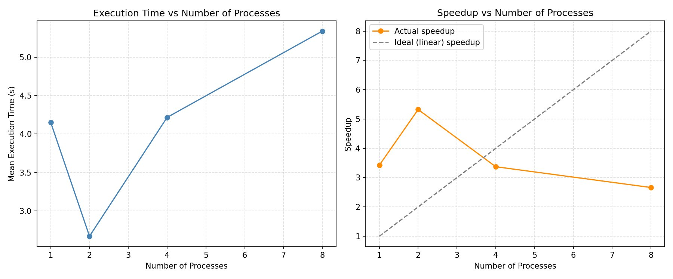
Left: mean execution time vs. P. Right: actual speedup vs. ideal (linear) speedup. Baseline: NumPy at 14.22s, chunk=50.

Processes (P) | Time (s) | Speedup | vs Ideal
NumPy baseline | 14.22s | 1.00× | —
1 | 4.15s | 3.42× | 3.42× above ideal
2 | 2.67s | 5.32× | 2.66× above ideal
4 | 4.22s | 3.37× | 0.84× of ideal
8 | 5.34s | 2.66× | 0.33× of ideal
Execution time and speedup relative to NumPy baseline for each process count.

With a single worker process (P=1), the multiprocessing achieves a 3.42x speedup over the NumPy baseline. The baseline processes all pixels for up to 100 iterations. The chunked implementations can break out of the iteration loop as soon as all points in a chunk have diverged.

At P=2, the speedup peaks at 5.32x—more than twice the number of workers. This result combines the early-exit benefit with actual parallelism across two cores. Beyond P=2, the performance deteriorates sharply. At P=4 the time rises to 4.22s (3.37x) and at P=8 it reaches to 5.34s (2.66x). This pattern strongly suggests that the test machine has 2 physical performance cores.

Dask
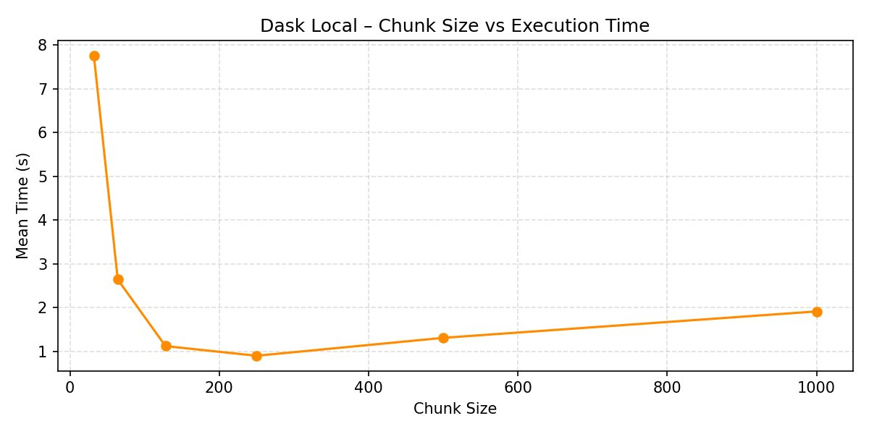
Dask local execution time vs. chunk size. Grid: 1000×1000, max_iter=100, 3 repetitions.

Chunk size | Time (s) | Note
32 | 7.76s | Very high scheduler overhead
64 | 2.64s | Overhead still dominant
128 | 1.12s | Good
250 | 0.90s | Optimal — ~1MB per chunk
500 | 1.31s | Slightly too large
1000 | 1.91s | Chunks too big, poor parallelism
Dask local execution times by chunk size.

The Dask chunk size curve follows a clear bowl shape with a minimum at chunk=250 (0.90s). This is consistent with Assignment Note 1, which suggests that on a local machine, chunk sizes that fit in the L2/L3 cache tend to perform best. At chunk=250, each block is 250×250 complex128 values = 250×250×16 bytes ≈ 1 MB, which fits comfortably in L3 cache on most modern processors.
Below chunk=128, the Dask task scheduler overhead dominates. A 1000×1000 grid split into 32×32 chunks produces (1000÷32)² ≈ 976 tasks — the scheduler spends more time managing tasks than the workers spend computing them. Above chunk=500, chunks are large enough that the available cores are underutilized and the early-exit benefit per chunk is reduced.

Dask vs NumPy
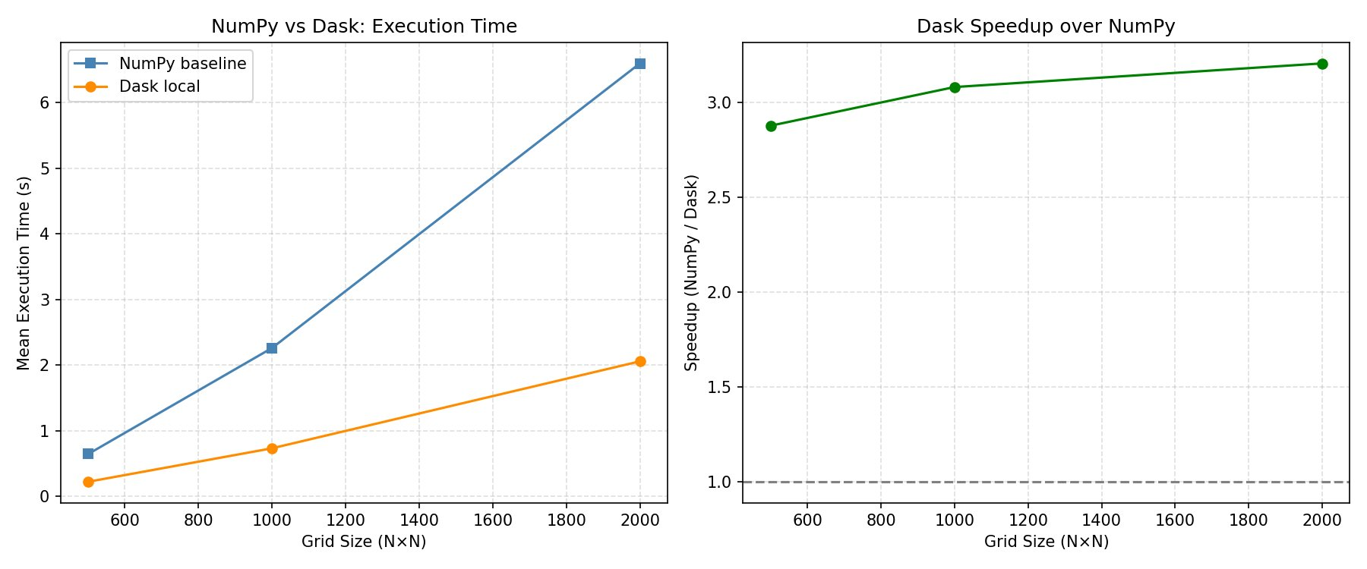
Left: NumPy vs Dask execution time across grid sizes. Right: Dask speedup over NumPy.

Grid size | NumPy time | Dask time | Speedup
500 × 500 | 0.65s | 0.23s | 2.88×
1000 × 1000 | 2.26s | 0.73s | 3.08×
2000 × 2000 | 6.60s | 2.06s | 3.20×
NumPy baseline vs Dask local times for increasing grid sizes (chunk=250).

Unlike the multiprocessing results, Dask outperforms the NumPy baseline at every problem size, including the smallest (2.88× at 500×500). This is because Dask's local scheduler uses threads rather than separate processes, meaning there is no inter-process serialization cost. The speedup grows slightly with problem size (2.88× → 3.20×), which is expected: the fixed scheduling overhead becomes proportionally smaller as the computation grows, and larger grids provide more work to distribute across cores.

Conclusion
This assignment implemented the Mandelbrot fractal algorithm in three ways — a NumPy vectorized baseline, a multiprocessing parallel version, and a Dask version — and conducted a systematic benchmarking study across chunk sizes, process counts, and problem sizes. Overall, the assignment demonstrated that high-performance parallel computing requires careful consideration of hardware characteristics, framework overhead, and algorithmic optimisations together.

